From: http://www.top10homeremedies.com/home-remedies/home-remedies-for-gout.html
The above website refers to an article published by the American College of Rheumatology in 2012 which has an abstract that says:
OBJECTIVE: To study the relationship between cherry intake and the risk of recurrent gout attacks among individuals with gout.
METHODS: We conducted a case-crossover study to examine the associations of a set of putative risk factors with recurrent gout attacks. Individuals with gout were prospectively recruited and followed up online for 1 year. Participants were asked to provide the following information regarding gout attacks: the onset date of the gout attack, symptoms and signs, medications (including antigout medications), and exposure to potential risk factors (including daily intake of cherries and cherry extract) during the 2-day period prior to the gout attack. We assessed the same exposure information over 2-day control periods. We estimated the risk of recurrent gout attacks related to cherry intake using conditional logistic regression. Odds ratios (ORs) and 95% confidence intervals (95% CIs) were calculated.
RESULTS: Our study included 633 individuals with gout. Cherry intake over a 2-day period was associated with a 35% lower risk of gout attacks compared with no intake (multivariate OR 0.65 [95% CI 0.50-0.85]). Cherry extract intake showed a similar inverse association (multivariate OR 0.55 [95% CI 0.30-0.98]). The effect of cherry intake persisted across subgroups stratified by sex, obesity status, purine intake, alcohol use, diuretic use, and use of antigout medications. When cherry intake was combined with allopurinol use, the risk of gout attacks was 75% lower than during periods without either exposure (OR 0.25 [95% CI 0.15-0.42]).
CONCLUSION: These findings suggest that cherry intake is associated with a lower risk of gout attacks.
Copyright © 2012 by the American College of Rheumatology.
[The rest is the content of the "Top Ten Remedies for Gout" website]
Gout is a type of arthritis that can affect different body parts like the ears, small joints on the hands, wrists, ankles or knees. Symptoms frequently include acute pain, swelling, intense tenderness and inflammation in the joints.
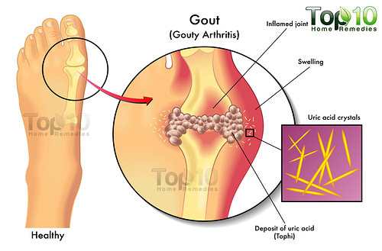
The exact cause is unknown, but a high amount of uric acid in the body is one of the reasons. Some other possible causes are genetics, excessive consumption of alcohol, lack of physical exercise, excessive protein intake and too much stress.
Gout is linked to other types of health problems, such as hypertension, diabetes, and uric acid kidney stones, so it is important to get proper medical treatment. In addition, some easy-to-follow home treatments can promote healing and provide symptom relief.


Here are the top 10 home remedies for gout.

1. Apple Cider Vinegar
Apple cider vinegar, which is used to treat headaches and acid stomach, also helps treat gout and arthritis. The acidity in apple cider vinegar will help relieve acute pain. You can also add honey to the remedy to boost the body’s anti-inflammatory response.

- Mix one teaspoon of raw, unfiltered apple cider vinegar in a glass of water.
- Drink it two to three times daily.
If you find this remedy helpful, you can increase the dosage of apple cider vinegar to up to two tablespoons.

2. Ginger Root
The anti-inflammatory properties present in ginger root can be very helpful in relieving pain and inflammation. There are many ways to use ginger root in the treatment of gout.
- Mix equal amounts of fenugreek powder, turmeric powder and dried ginger root powder (sonth). Have one teaspoon of this mixture along with warm water. Take it twice daily.
- You can simply add ginger root in cooking recipes, or eat a small, raw piece of ginger root daily.
- You can also add one-half teaspoon of ginger root to one cup of boiling water and mix it well. Drink this solution at least once daily.
- Another option is to make a paste of ginger root with a little water and apply this paste on the affected area. Leave it on for about half an hour. Do this once daily.

3. Baking Soda
One significant factor contributing to gout is an increase of uric acid in the body. Baking soda can help lower the amount of uric acid, giving you relief from the pain.
- Mix one-half teaspoon of baking soda in a glass of water.
- Drink this solution four times a day but not more than that.
- Continue up to two weeks.
If you are above 60 years, do not take more than three times in a day. Also, ignore this remedy if you suffer from hypertension.

4. Lemon Juice
To get relief from gout pain, it is essential to alkalize the body and neutralize the excess uric acid in blood stream. This can be done easily with fresh lemon juice and baking soda. Along with lemon juice, also eat other fruits rich in vitamin C to strengthen the body tissues.
- Mix the juice of one lemon with one-half teaspoon of baking soda. Let it sit for a few seconds until the fizzing stops, and then mix it in a glass of water. Drink it immediately.
- Another option is to add the juice of half a lemon to a glass of water and drink it three times a day.

5. Cherries
Cherries, whether sweet or sour, can also be very helpful in treating gout due to their antioxidant properties. Cherries also contain anthocyanins, which can reduce inflammation as well as minimize gout flare-ups.
- For gout patients, eating 15 to 20 cherries a day is highly recommended. For better results, start your day with some cherries.
- Another option is to drink a glass of black cherry juice daily. You can also add a few minced garlic cloves in it.

6. Epsom Salt
Epsom salt is another useful ingredient for home treatment of gout and other forms of arthritis. The high amount of magnesium present in Epsom salt will also improve the condition of your heart and lower high blood pressure. Soaking the affected body part in warm water mixed with Epsom salt relaxes aching muscles and relieves pain.

- For a leisurely bath, add two cups of Epsom salt to warm bath water.
- Soak your body in it until the water starts losing heat.
- Do this once a week. If you have severe gout, you can try it two or three times a week.

7. Bananas
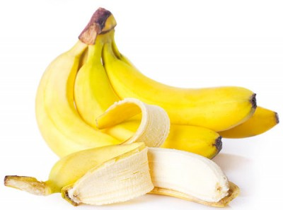
Bananas are also very effective in treating gout. The high potassium content in bananas will help convert uric acid crystals into liquid form that will be flushed out of the body later through urination. Bananas also contain moderate amounts of vitamin C, which can be very effective in managing swelling and pain.
- Simply eat one or two bananas daily, and soon you will notice improvement in your condition.
- Another option is to add one ripe banana to one-half cup of yogurt. This will also help to keep diarrhea away.

8. Apples

It is very common to hear people say, “An apple a day keeps the doctor away.” It’s a good, healthy habit to eat at least one apple daily, especially when you have gout.
Experts suggest eating an apple after each meal. The malic acid present in apples will help neutralize uric acid in the body and thereby relieve gout pain and inflammation. If you do not like to eat apples, you can try apple juice. Along with an apple, it is also a good idea to eat raw carrots daily.

9. Activated Charcoal
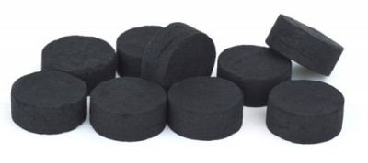
Activated charcoal is known to absorb uric acid; hence, it can be safely used for gout treatment. Those suffering from gout should take a charcoal bath twice or three times a week.
- Mix one-half cup of charcoal powder with some water until it forms a paste. Put the paste in a tub and add more water. Soak your affected body part for at least half an hour. This remedy is a good solution for gout in the ankle joint or big toe.
- For other affected body parts, make a charcoal paste and apply it on the skin. Leave it on for half an hour; then rinse it off with lukewarm water.
- Alternatively, you can take activated charcoal capsules orally to relieve gout pain and inflammation. Consult your doctor before using this option.

10. Cold Water
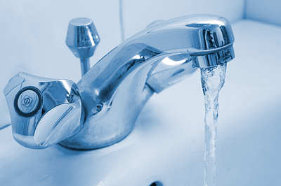
Placing the affected area in cold water will reduce swelling as well as pain. When you have gout, do not use ice directly on the skin; it can damage the skin and make your condition worse.
- Immerse the inflamed, swollen joint in cold water for 10 to 15 minutes. Repeat the process several times a day.
- You can use an ice pack for about 15 minutes, but wrap it in a towel before placing it on the affected area. Do this twice a day. Avoid excess use of ice packs because it can lead to crystallization of uric acid.
So, if you are suffering from gout, simply try these natural remedies to get relief from the pain and inflammation. Bear in mind, there is no quick cure. Time and determination are required to treat gout.

Resources:
www.ncbi.nlm.nih.gov/pubmed/23023818

